WEEK 1 TASK REPORT
DASHBOARD PLANNING AND DESIGN STRATEGY
Superstore Sales & Profit Performance Dashboard
Dataset: Tableau Sample – Superstore
1. Objective
The objective of this task is to plan and design an interactive Tableau dashboard for analyzing Superstore sales and profit performance. The dashboard is planned to present important business metrics, sales trends, category performance, regional performance, sub-category performance, and the relationship between discount and profit in a clear and interactive format. The design focuses on creating a simple data story that allows users to move from an overall performance view to detailed comparisons.
2. Target Audience
The dashboard is intended for business managers, sales managers, business analysts, and decision makers who need a quick understanding of sales and profitability.
- Business Managers – monitor overall performance and identify areas requiring attention.
- Sales Managers – compare sales across categories, regions, and time periods.
- Business Analysts – explore trends and relationships in the data.
- Decision Makers – use summarized KPIs and visual comparisons for business decisions.
3. Dashboard Conceptualization and Data Story
The dashboard follows a top-to-bottom data story. First, KPI cards provide an immediate summary of Total Sales, Total Profit, and Total Orders. Next, the sales trend explains how performance changes over time. Category, profit, and regional charts then support direct comparisons. Finally, Discount vs Profit and Sales by Sub-Category provide deeper analysis. This structure helps users start with the big picture and progressively investigate possible business drivers.
4. Key Metrics and Visual Elements
Metric / Visual | Purpose | Planned Use
Total Sales | Measure overall sales performance. | KPI card
Total Profit | Measure overall profitability. | KPI card
Total Orders | Measure order volume. | KPI card
Sales Trend Over Time | Identify monthly changes, peaks and drops. | Line chart
Sales by Category | Compare sales across product categories. | Bar chart
Profit by Category | Compare profitability across categories. | Horizontal bar chart
Sales by Region | Compare regional sales performance. | Bar chart
Discount vs Profit | Study the relationship between discount and profit. | Scatter plot
Sales by Sub-Category | Identify high- and low-performing sub-categories. | Bar chart

5. Layout Strategy
The dashboard uses a clean grid-based layout. The title and filters are positioned at the top for visibility. The sales trend occupies the first major area because time-based movement is an important part of the data story. KPI cards are placed directly below it so users can read the overall values quickly. Comparison charts form the middle section, while detailed relationship and sub-category analysis are positioned at the bottom.

5.1 Dashboard Mock-up / Wireframe
TITLE + FILTERS
SALES TREND OVER TIME
TOTAL SALES | TOTAL PROFIT | TOTAL ORDERS
SALES BY CATEGORY | PROFIT BY CATEGORY | SALES BY REGION
DISCOUNT VS PROFIT |  | SALES BY SUB-CATEGORY
Figure 1. Planned dashboard wireframe showing the relative position of major KPIs, charts, filters, and interaction areas.
6. Color, Typography and Design Strategy
- Use a clean white or light background to maintain readability.
- Use a consistent blue tone for major sales and comparison visuals.
- Use orange as an accent for the Discount vs Profit relationship visual.
- Use clear dark titles and labels with consistent typography.
- Avoid unnecessary decoration so that the data remains the primary focus.
- Maintain consistent spacing and alignment between dashboard objects.
7. Filters and Interactivity
The planned dashboard includes interactive filters for Region, Order Date, and Category. These controls allow users to change the analysis dynamically without leaving the dashboard.
- Region Filter – compare or focus on a particular geographic region.
- Order Date Filter – analyze a selected time period.
- Category Filter – focus on Furniture, Office Supplies, or Technology.
- Interactive filtering allows the charts and KPI values to update together.
8. Integration Rationale
Each visualization has a specific role in the overall data story. KPI cards provide immediate summary values, while the line chart explains how sales change over time. Bar charts are used for straightforward category and regional comparisons because differences can be recognized quickly. The scatter plot adds relationship analysis by showing how discount levels relate to profit. The sub-category chart provides a deeper level of detail. Together, these elements combine overview, comparison, trend, and relationship analysis in one coherent dashboard.
9. Strategic Business Insights
- Technology is a strong contributor to overall sales performance.
- Regional sales vary significantly, making regional comparison useful for management.
- Profit contribution differs across categories, so high sales should not be treated as the only measure of success.
- Higher discounts do not automatically guarantee higher profit; discount and profitability should be evaluated together.
- Monthly sales movement shows peaks and drops that can support further investigation of seasonal or business factors.
- Sub-category analysis helps identify detailed areas that contribute strongly to sales.
10. Tableau Dashboard Implementation
The planned design was translated into a Tableau dashboard using KPI cards, a line chart, bar charts, a scatter plot, filters, and a structured grid layout.
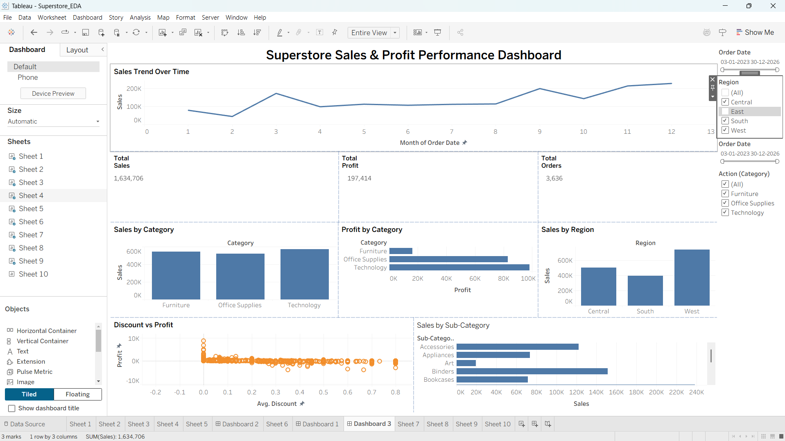
Figure 2. Implemented Superstore Sales & Profit Performance Dashboard.
11. How the Design Enhances User Understanding
The design reduces the effort required to understand the dataset by grouping related information into logical sections. Users can first read the KPI cards for a quick summary, then examine the trend and comparison charts, and finally investigate discount and sub-category details. Filters make the dashboard interactive and allow users to answer focused questions. Consistent formatting, simple chart types, clear titles, and limited visual clutter improve readability and support faster decision making.

12. Documentation and Development Process
- Defined the dashboard objective and intended audience.
- Identified the most useful KPIs and business questions.
- Selected visualizations according to the type of analysis required.
- Planned the dashboard layout using a wireframe.
- Defined filters and interaction points.
- Established a consistent visual and color strategy.
- Implemented the planned design in Tableau and reviewed the resulting dashboard.
- Prepared the dashboard screenshot as evidence of implementation.
13. Conclusion
The Superstore Sales & Profit Performance Dashboard provides an interactive and user-friendly approach to analyzing sales, profit, orders, category performance, regional performance, and discount relationships. The documented layout, visual choices, filters, and design principles form a clear blueprint for dashboard development. The combination of summary KPIs and detailed visual analysis supports both quick monitoring and deeper business investigation.
14. Report Description for Submission
This Week 2 project focuses on planning and designing an interactive Tableau dashboard for Superstore sales and profit analysis. The report documents the complete dashboard planning process, including the objective, target audience, key performance indicators, visualization selection, layout strategy, color and typography choices, filters, interaction points, and integration rationale. The proposed dashboard is designed to present Total Sales, Total Profit, and Total Orders as KPI cards, followed by a Sales Trend Over Time for understanding monthly movement. Category, profit, regional, and sub-category visualizations are included to support business comparisons. A Discount vs Profit scatter plot is used to explore the relationship between discount levels and profitability. A wireframe mock-up is provided to explain the planned placement of dashboard elements before implementation. The report also explains how the selected visuals work together to create a coherent data story and improve user understanding. Interactive filters such as Region, Order Date, and Category allow users to explore specific business areas dynamically. The design emphasizes clarity, consistent formatting, minimal visual clutter, and easy comparison. The final Tableau dashboard screenshot is included as evidence that the planned strategy was translated into an actual dashboard. Overall, this document acts as a blueprint for building and refining an effective business intelligence dashboard and demonstrates the reasoning behind each major design decision.

